Theme 3 –evolution and revolution as organisations grow- Larry Greiner
Intro:
- Problems of companies going bankrupt after they have served their purpose is rooted more in past decisions than in present events or market dynamics.
- Management in its haste to grow often overlooks critical development questions such as ‘where has our org been?’ and ‘where is it now’
- Series of development phases -,each phase begins with a period of evolution with steady growth and stability and ends with a revolutionary period of org turmoil and change. The resolution of each phase decides whether or not company moves forward.
http://www.google.ie/imgres?um=1&hl=en&sa=N&tbo=d&authuser=0&biw=1280&bih=709&tbm=isch&tbnid=oQp6KSd5bxGSSM:&imgrefurl=http://www.emeraldinsight.com/journals.htm%3Farticleid%3D850707%26show%3Dhtml%26WT.mc_id%3Dalsoread%26PHPSESSID%3Ddlibpe9g7875dklcag72sqhil4&docid=fLeAvNvcj1KphM&imgurl=http://www.emeraldinsight.com/content_images/fig/0680080103001.png&w=513&h=373&ei=3i7oUP2bJ4SwhAes34A4&zoom=1&iact=hc&vpx=392&vpy=186&dur=955&hovh=191&hovw=263&tx=142&ty=89&sig=118061971598739009685&page=1&tbnh=144&tbnw=198&start=0&ndsp=23&ved=1t:429,r:2,s:0,i:93
A model of how organisations develop:
- Five key dimensions emerge- age and size, stages of evolution and revolution and the growth rate of industry.
- Age of an organisation:
- most essential dimension for any model of development is life span of org. Managerial problems and practices are rooted in time.
- They don’t last throughout the life of an org. Passage of time also contributes to institutionalisation of managerial attitudes.
- They become rigid and outdated more predictable behaviour which is difficult to change.
- Size of an organisation:
- The vertical axis.
- Companies problems and solutions change as number of employees and its sales volumes increase.
- Problems of coordination and communication magnify, new functions emerge, jobs become more interrelated.
- Stages of Evolution:
- As org age and grow, prolonged growth –‘evolutionary period’.
- Most growing orgs don’t expand for 2 years and then contract for 1, those that survive crisis enjoy 4-8 years of continuous growth without economic setback.
- Evolution- describes quite periods where only modest adjustments need to maintain growth under same overall pattern of growth.

- Stages of Revolution:
- Cannot be assumed evolution growth is linear. Normally periods of turmoil followed by calm periods.
- Periods of turmoil-‘periods of revolution’ –typically exhibit period of upheaval of management practices.
- Old management practices of small company no longer effective- need to change.
- Critical task for management during this period is to find a new set of org practices that will become the basis for managing the next period of evolutionary growth.- as time goes on solution becomes the problem.
- Growth rate of the industry:
- Speed at which an org experiences phases of evolution and revolution closely related to market environment of its industry.
- EG company in rapidly expanding market will have to add employees quickly hence need for new org structures to accommodate large staff increases.
- Evolution can also be prolonged and revolutions delayed when profits come easily.
Phases of Growth:
- Must now analyse the model into five separate stages.
- Each successive stage is the cause of the previous stage. To move on industry must adopt a new style but not the previous style.
- Phase 1 – Creativity:
- Creating both a product and a market
- Founders of company usually technically or entrepreneurially orientated, disdain management activities, focus on making and selling a new product.
- Communication among employees is frequent and informal.
- Long hours of work are rewarded by modest salaries and promises of ownership benefits.
- Decisions and motivation are highly sensitive to marketplace feedback, management acts as customers react.
- All above points needed for company to get up off ground, but as company grows these become the problem
- More employees- requires different knowledge, cannot communicate informally, new employees unmotivated.
- Company’s founders find themselves burdened with unwanted managerial responsibilities.
- Conflicts among harried leaders emerge and grow more intense. At this point crisis of leadership occurs – onset of first revolution.
- Strong business manager is needed to lead company and pull the organisation together.
- Phase 2 –Direction:
- Companies which survive phase one by employing a suitable manager undergo period of sustained growth. Characteristics of evolutionary period:
- Functional org structure is introduced to separate manufacturing form marketing, job assignments become increasingly specialised.
- Accounting systems introduced for purchases and inventory.
- Communication more formal and impersonal as hierarchy of titles and positions grow.
- Incentives, budgets and work standards adopted.
- New manager and key supervisors assume responsibility for instituting direction, low-level supervisors treated as functional specialists.
- New directive techniques channel employees energy into growth, they eventually become inappropriate for controlling a more diverse and complex org.
- Low-level employees restricted by centralised hierarchy, they’ve come to possess more direct knowledge about markets and machinery that their leaders but are torn between following procedures and having initiative.
- Second revolution emerges from crisis of autonomy. Solution is to move toward direct delegation
- Phase 3- Delegation:
- Next era of growth evolves from successful application of a decentralised org structure. Characteristics:
- Greater responsibility given to managers of plants and market territories.
- Profit centres and bonuses used to motivate employees.
- Top level executives limit themselves to managing by exception based on periodic reports from the field.
- Management often concentrates on acquiring outside enterprises that can ve lined up with other decentralised units.
- Communication from top is infrequent and occurs by phone or brief visits.
- Delegation phase allows company to expand by means of heightened motivation of managers at lower levels
- Managers in decentralised orgs who have greater authority and incentives are able to penetrate larger markets, respond faster to customers and develop new products.
- Top level executives feel there losing control over highly diversified field operation. Freedom breeds a parochial attitude.
- Soon organisation fall into a crisis of control. Phase 3 revolution begins when top managers seek to regain control over company as a whole.
- Those companies that move ahead find a new solution in the use of special coordination techniques.
- Phase 4 – Coordination:
- Characterised by use of formal systems for achieving greater coordination and by top level executives taking responsibility for the initiation and administration of these new systems.
- Decentralised units are merged into product groups.
- Formal planning procedures are established and intensively reviewed.
- New staff members hired and located at hq to initiate companywide programs of control and review for line managers.
- Capital expenditure are carefully weighted and parcelled across the org.
- Each product group is treated as an investment center where return on invested capital is an important criteria used in allocating funds.
- Certain technological functions are centralised at hq while daily operating decision remain decentralised.
- Stock options and companywide profit sharing used to encourage employees to identify with the org as a whole.
- New coordination system prove usefull for achieving growth through more efficient allocation of a companys limited resources.
- These systems promp fild managers to look beyond the need of local units. Managers still have great deal of decision making responsibility they learn to justify their actions carefully.
- A lack of confidence builds up between line and staff and between hq and field. The systems and programs introduced begin to exceed their usefulness.
- A red tape crisis occurs. Both groups criticise the bureaucratic system that has evolved. Procedures take precendence over problem sloving and innovation dims.
- In short org has become too large and complex to be managed through formal programs and rigid systems. Phase 4 revolution underway.

- Phase 5 – Collaboration:
- Last observable phase emphasises strong interpersonal collaboration in an attempt to overcome red tape crisis.
- Phase 5 emphasises spontaneity in management action through teams and the skilful confrontation of interpersonal differences.
- Social difference and self discipline replace formal control.
- Phase 5 evolution builds around a more flexible and behavioural approach to management.
- Focus on solving problems quickly through team action.
- Teams combined across functions to handle specific tasks.
- Staff experts at HQ are reduced, reassigned, combined into interdisciplinary teams that consult with field units.
- Matrix type structure used to assemble right team for problems.
- Formal control systems simplified and combined into multi purpose system.
- Conference of key managers held frequently to focus on major problems.
- Educational programms used to train managers in behavioural skills
- Economic rewards geared towards team work not individual.
- Experimenting with new practices encouraged throughout org.
- What is the revolution in response to this evolution?
- ?program which allows employees to periodically est, reflect and revitalise.
- Change from reflective to work etc, rotation key.
Implications of history:
- Know where you are in the development sequence. – being aware when change is needed in a particular stage.
- Do not skip phases out of impatience because of learning outcomes and strengths.
- Recognise the limited range of solutions. – pick new solution not tried before, do not go backwards.
- Realise that solutions breed new problems. Actions in the past determine much of what will happen in the future.
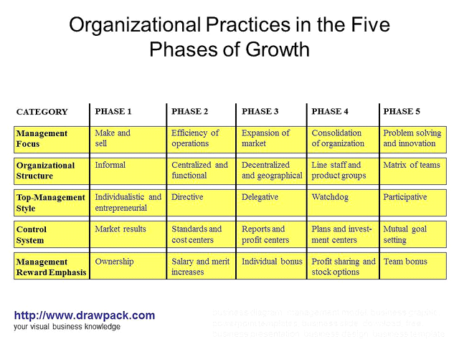
Revolution is still inevitable:
- Four basic principles still seem valid.
- First still observe major phases of development in the life of growing companies. Each phase contains its own unique structute, systems and leadership.
- Second, transitions between developmental phases still don not occur naturally.
- Third, logic of paradox underlying the modle continues to ring true.
- Fourth, greatest resistance to change appears at the top because revolution often means that units under each senior executive will be eliminated or transformed.
- Much more orgs do not make it past certain stages and fail. – often get acquired by companies in the later stages.
- Phases not as cleary marked off as depicted.
- Also mini phases within each major phase.
- Phase 5- matrix confined largely to senior management.
- Psychological saturation wrong, crisis is one of realising that there is no internal solution for stimulation further growth. Org looks outside for partners or opportunities.
- A sixth phase may be evolving which growth depends on the design of extra organisational solutions such as creating a holding company.

